|  |  |  |
| --- | --- | --- |
| **C++ Programming** | **Student**  **number** | **21300691** |
| **Homework 5** | **Name** | **Cheung, Won Sik** |

Code

Class People code

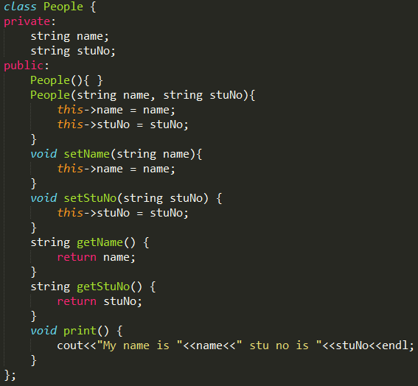

Class Team code

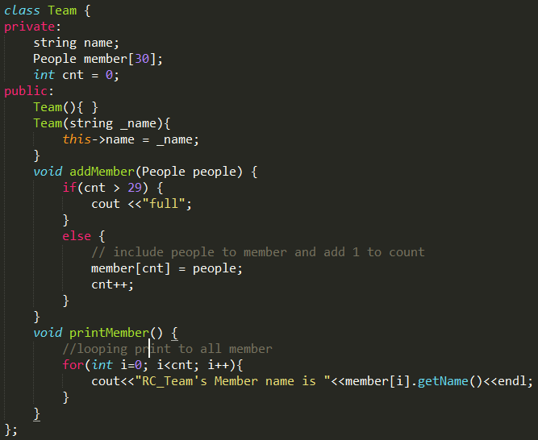

Main code

Replace name and student number

Add system(“pause”); to stop and watch the result

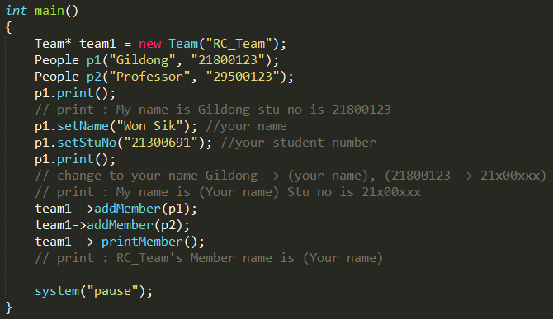

Result

